2026 DFT National Recruitment

Deanery/NHSE Local Office | Northern Ireland  Medical and Dental  Training Agency  (NIMDTA) | Deanery/NHSE Local Office website address | Dental Foundation Training – NIMDTA
Scheme Information | Name of Scheme/Area | Name of TPD | Site and usual day for Educational Programme (Day Release) | Start date
Scheme Information | Northern Ireland  Dental Foundation  Training Scheme | Siobhan Cushley  Alison Johnston  Anita Gallagher | Site to be confirmed; Antrim/  Belfast/ Newtownabbey | 1 September 2026
Geographical spread (towns usually included) Please note  - Training practices for 2026 have not yet been  appointed. Any information given on our website is for guidance only. | Dental practices hosting a Foundation Dentist are recruited on an annual basis.  Northern Ireland will be split into three schemes for the 2026-2027 training year, as outlined in the map below. Once the Educational Supervisor recruitment process is complete, practices will be allocated across the three schemes.
Local Allocation Process followed in 2026  (This may be subject to alteration for 2026). | Foundation Dentists will be required to undertake two ranking processes in the following order:-  - To rank all 3 schemes, A, B and C. Foundation Dentists will be allocated to one scheme based on their national recruitment outcome and their stated preferences. Allocation to Scheme A, B or C will therefore reflect both performance in recruitment and the individual’s scheme ranking.  - To rank Educational Supervisors (ES) within their allocated scheme. The highest-ranked Foundation Dentist will be matched with their highest-ranked ES preference, and this matching process will continue in ranking order until all ES positions within the scheme have been filled.  Two allocation panels will meet, one to allocate to a scheme and the second to allocate to an Educational Supervisor.  Following allocation, each Foundation Dentist will be advised of their Scheme Adviser/ Training Programme Director, who will support them throughout the year with training monitoring, ePortfolio requirements and general guidance.
 | 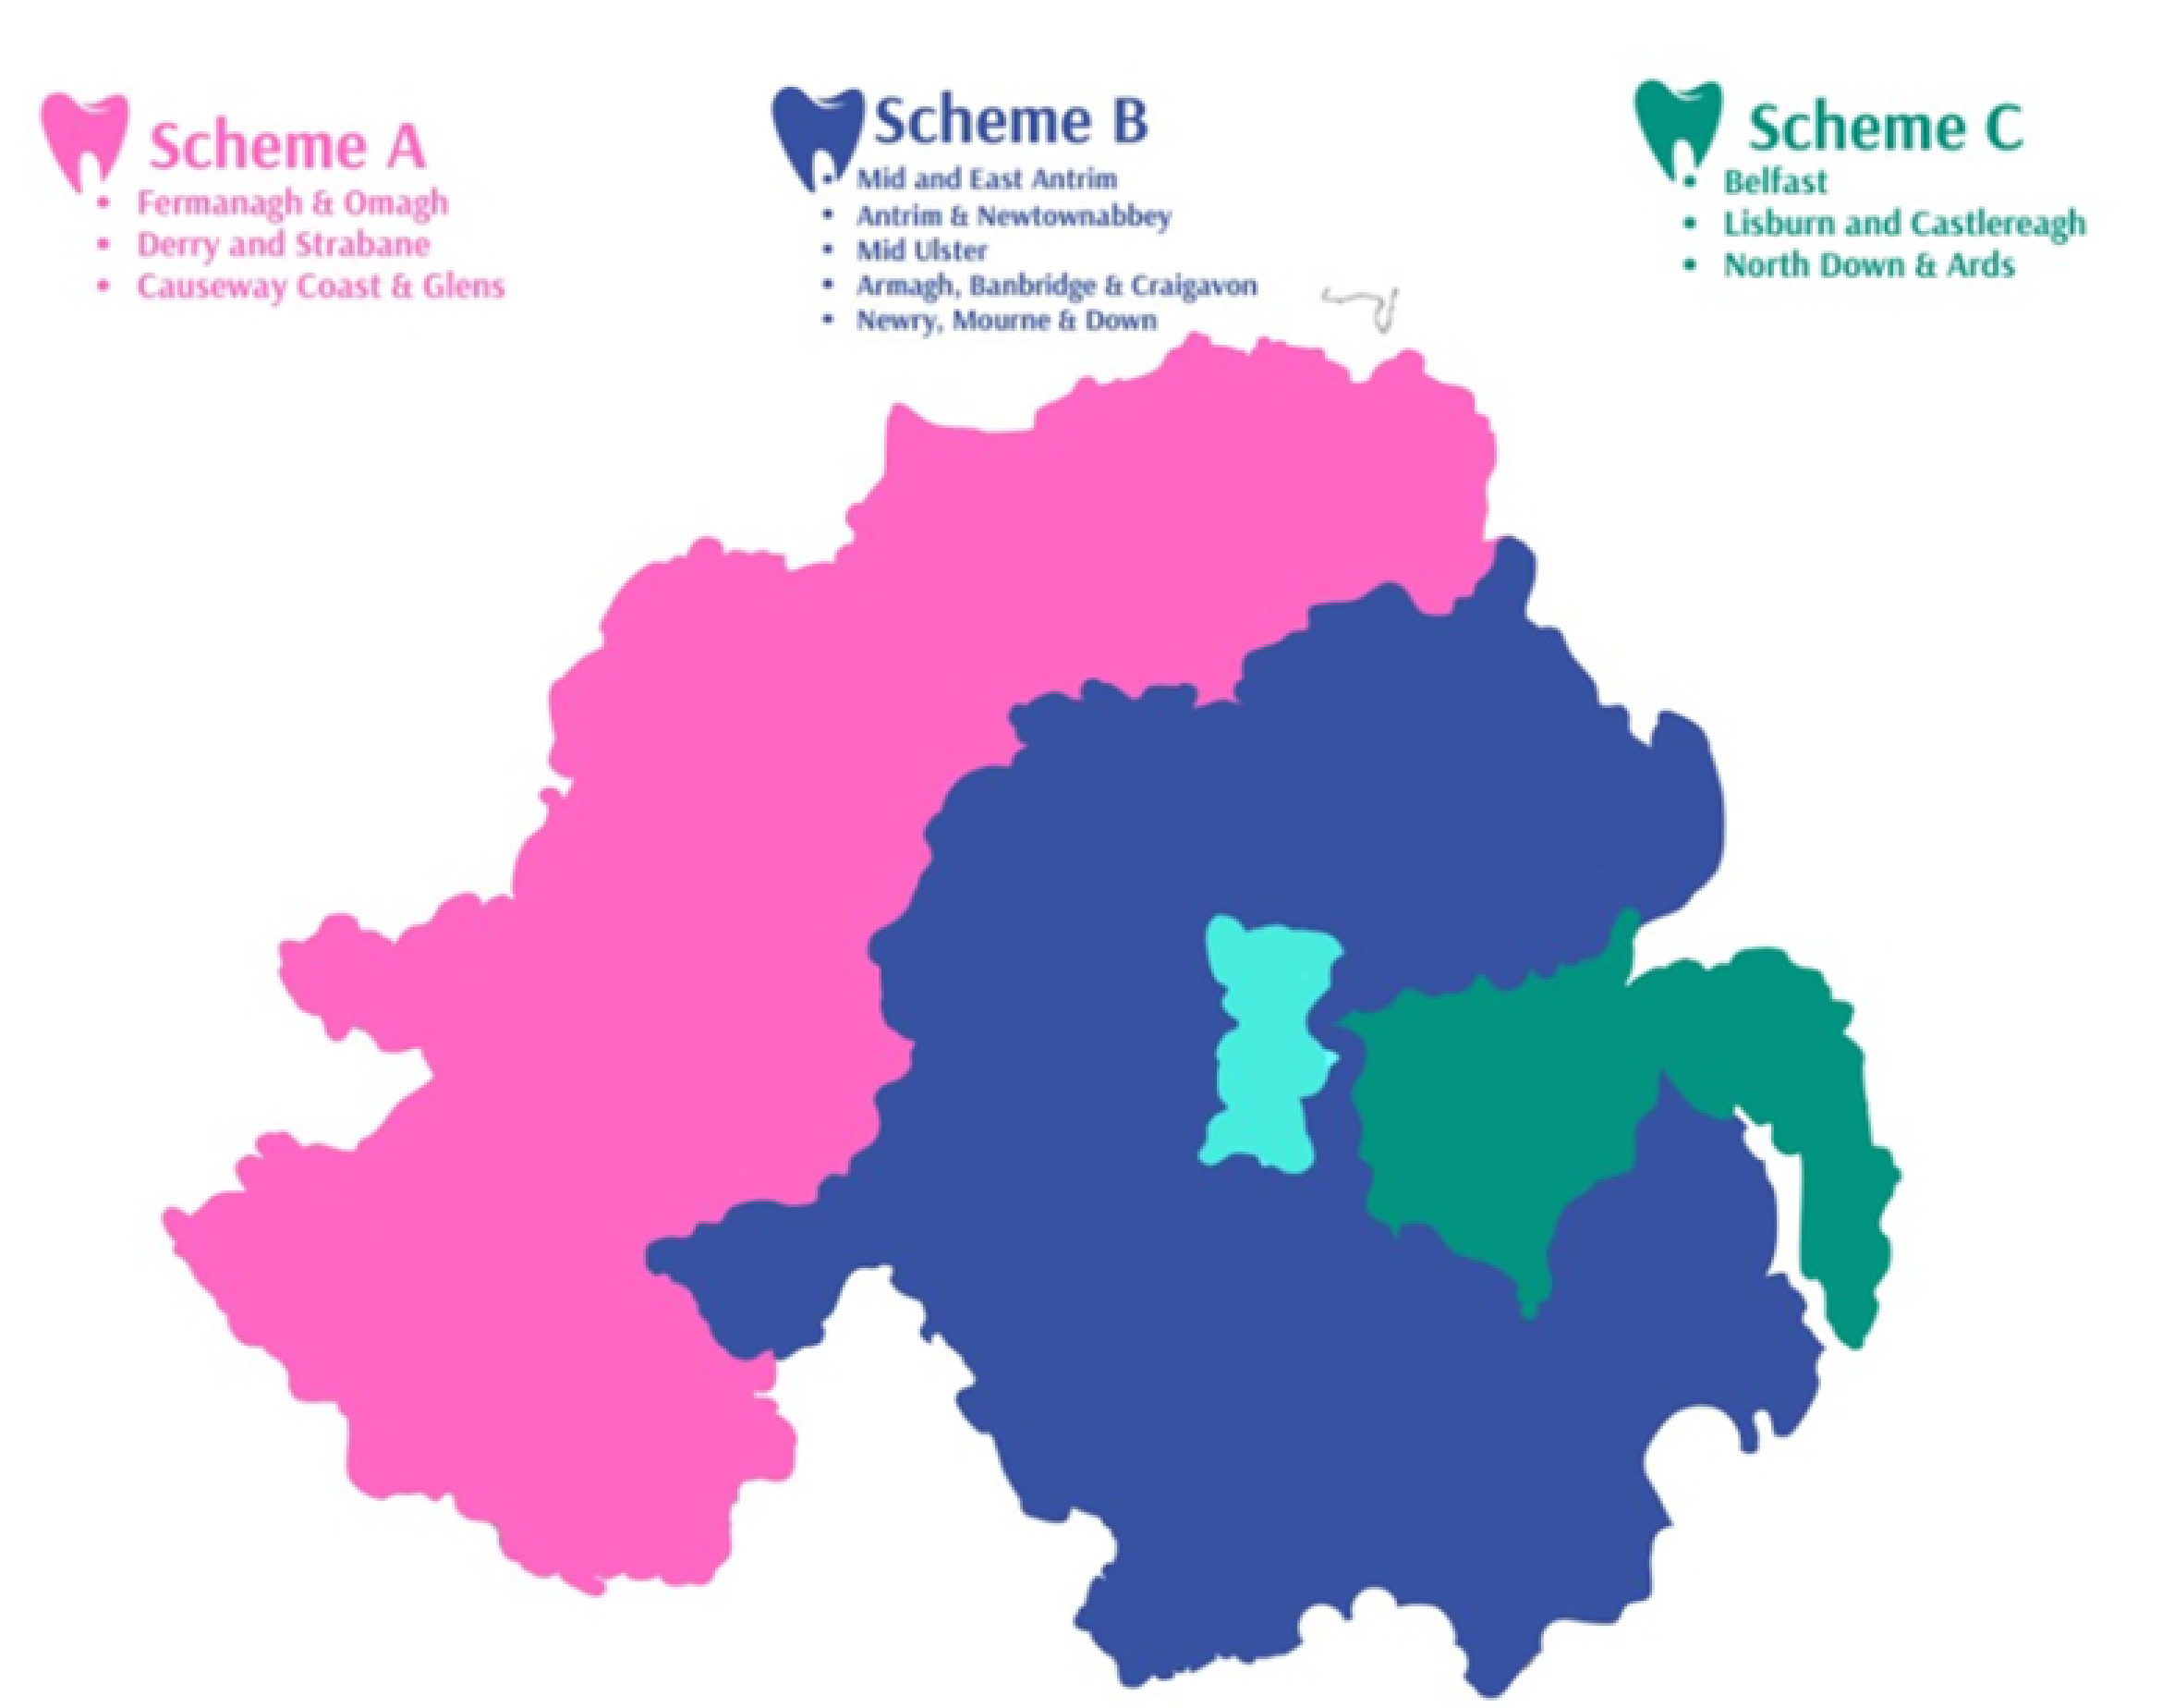

Overview | New to Northern Ireland  Information for Foundation Dentists new to Northern Ireland is available on the NIMDTA New to Northern Ireland - N2NI (nimdta.gov.uk) webpage (nimdta.gov.uk). This includes guidance on immigration, accommodation, finance and other useful support.  Educational Supervisors  Educational Supervisors are appointed through a rigorous selection process and training practices are regularly inspected to ensure they meet required standards. Supervisors are accessible in the workplace and play a key role in supporting Foundation Dentists throughout this developmental year. Many Supervisors return annually to train within the Northern Ireland scheme.  Training Year  Study Day Programme  All Foundation Dentists will participate in a day-release study programme comprising up to 30 study days. This face-to-face programme begins in September and concludes the following June. Training starts with a three-day induction, followed by weekly study days throughout the year.  Study days are delivered across various locations in Northern Ireland, with most sessions held in Antrim, Newtownabbey, and Belfast. Facilitators include specialists and local dental practitioners, offering a diverse educational experience that incorporates lectures, hands-on training and workshop-based learning.  At the beginning of the training year each Foundation Dentist will receive a Phantom Head for use throughout the programme. These study days also provide valuable opportunities to connect with peers, NIMDTA and Scheme Adviser/ Training Programme Director. Group interaction and peer support are actively encouraged.  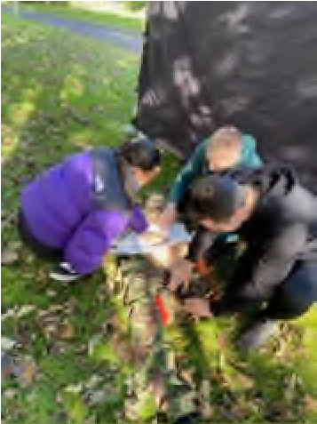

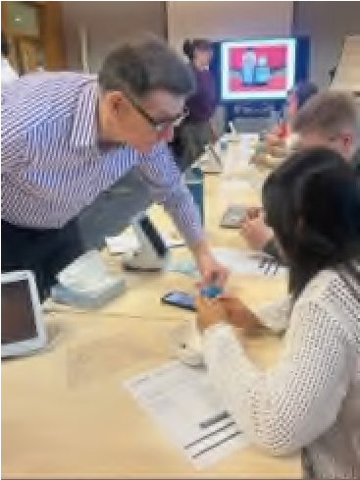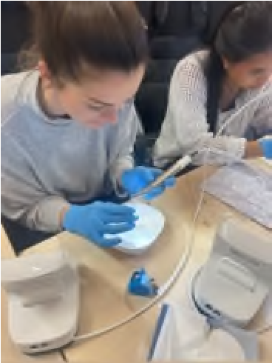

Simulation Training
Foundation Dentists will also have the opportunity to participate in Simulation Training as part of the Study Day programme (Dental Simulation Training (nimdta.gov.uk). NIMDTA’s Simulation Suite is equipped with 10 state-of-the-art simulators that use virtual reality technology to support the development and refinement of clinical skills. Each unit provides realistic haptic feedback, allowing users to experience the precise sensation of the materials and instruments they are working with throughout the training session.
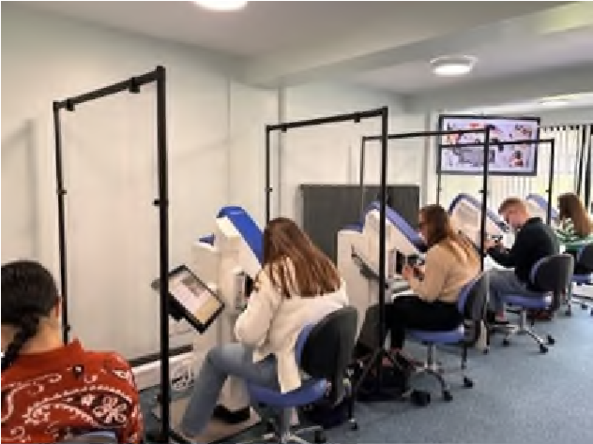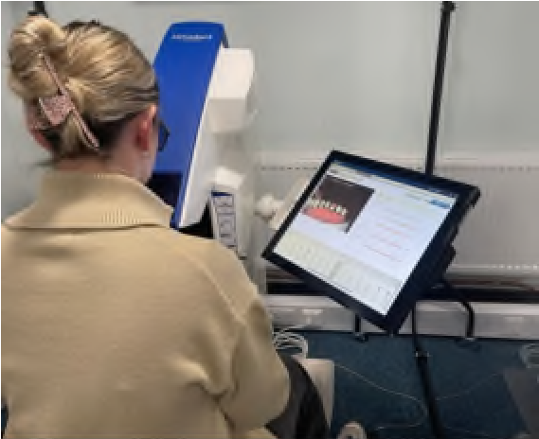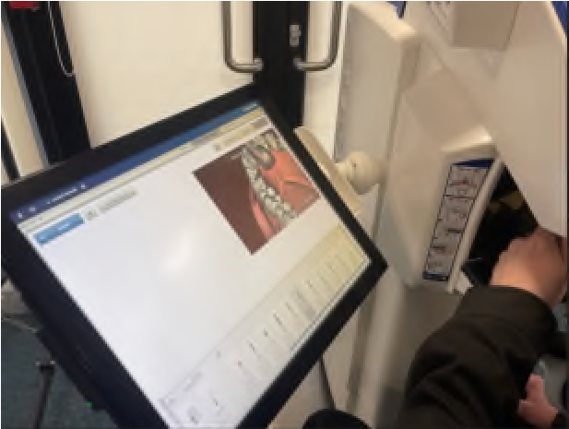

Shadowing Placements
Hospital shadowing placements were offered within the Belfast and Western Trusts during 2026. These placements provide Foundation Dentists with exposure to Restorative Dentistry, Oral Medicine and Oral Surgery outpatient clinics, including sessions involving local anaesthetic procedures, helping to broaden experience across these specialties. The placements also aim to support Foundation Dentists in exploring and considering future postgraduate Dental Core Training pathways by giving insight into the role and responsibilities of a Dental Core Trainee.

APLAN
All Foundation Dentists will participate in APLAN, Anonymous Peer Learning and Assessment Network, with anonymous review of Case Studies.

Dentaljuce
All Foundation Dentists will be provided with access to Dentaljuce, an online CPD portal, for the duration of the training year, Login | Enhanced Dental CPD Online (dentaljuce.com).

SCRIPT
Dental SCRIPT is an e-learning programme designed to enhance prescribing competency and is accessible through the Dental ePortfolio. It serves as an excellent learning resource and the module assessments enable Foundation Dentists to track their progress across all prescribing areas. The programme consists of 10 modules.

Assessment
Foundation Dentists will gain a broad range of experience within their training practices. Progress is monitored throughout the year through a combination of the ePortfolio, Review of Competency Progression (RCP) panels and scheduled meetings with the Scheme Adviser or Training Programme Director. Assessments are completed regularly within the ePortfolio, which serves as a key educational tool throughout the training period.

Dental Foundation Newsletters
Newsletters are produced every quarter and can be found at the following link. Dental Training Newsletters

Professional Support and Wellbeing
The Professional Support and Wellbeing (PSW) team is committed to helping Junior Doctors and Dentists reach their full career potential. The team is made up of Case Managers, Coaches and administrative staff all focused on placing trainee support and wellbeing at the centre of their work. PSW offers a range of services, including one-to-one support meetings, peer mentoring programmes, personal coaching, career guidance and exam support which includes assessment for dyslexia.

Salary
Foundation dentists are paid in line with the Statement of Dental Remuneration (SDR) Statement of Dental Remuneration (SDR) - Business Services Organisation (BSO) Website. Please note that the figure published and applicable at the date of application may not be the same as that in force at the time of starting in post.

NIMDTA Opportunities

FD Representative
Each year, Foundation Dentists elect a Representative. A key part of this role is to attend the Committee on Dental Foundation
Training, Northern Ireland (CDFT(NI)) to provide feedback on the training scheme, as well as the DFT/QUB Dental School
Liaison Group. The Foundation Dentist Representative also takes part in NIMDTA’s annual Fifth Year Student Open Evening and NIMDTA’s Dental Welcome Evening. In addition, they are a member of the NIMDTA Dental Trainee Representative Forum, meeting twice a year alongside Dental Core and Specialty Trainee Representatives.

NIMDTA Ambassador
NIMDTA offers trainees the opportunity to apply for the role of Trainee Ambassador during the training year (NIMDTA Trainee Ambassador Recruitment). The Trainee Ambassador role has been developed in line with the VALUED strategy, with the key aims of:
- Promoting connections between trainees.
- Highlighting the benefits of training.
- Strengthening the relationship between NIMDTA and trainees.

