2026 DFT National Recruitment

Deanery/NHSE Local Office | Health Education and Improvement Wales (HEIW) | Deanery/NHSE Local Office website address | HEIW - DFT Schemes
Scheme Information | Name of Scheme/Area | Name of TPD | Site and usual day for Educational Programme (Day Release) | Start date
Scheme Information | Swansea Vale | Richard Jones | Study Days at Prince Charles Hospital, Gurnos Rd, Merthyr Tydfil CF47 9DT - Tuesday  Please note the study days will be delivered as a blended approach. | 01 September
Geographical spread (towns usually included) Please note - Training practices for 2026 have not yet been appointed. Any information given on our website is for guidance only. | 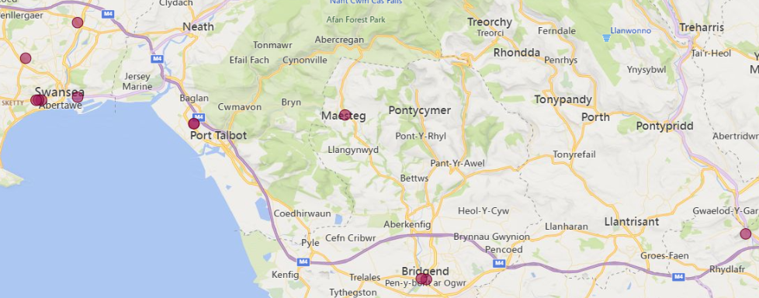  (This map is based on practices approved for the 2025/2026 training year)
Local Allocation Process followed in 2026  (This may be subject to alteration for 2026). | The National Recruitment process will allocate you, if appropriate, to the Swansea Vale DFT scheme. In line with the rest of the UK, Wales will conduct a local allocation process. Once allocated to your scheme, FDs will be provided with a link to view a profile of each practice on the scheme within the local preferencing window. FDs will be required to submit preferences to HEIW who will allocate based on the FDs National Recruitment ranking. The preferencing window is 10 – 15 June 2026  If you are allocated to the Swansea Vale scheme, the Dental Foundation Training Manager will send you further information in June 2026.
Overview | Health care in Wales is a devolved responsibility overseen by the Welsh Government.  As a result, the Welsh General Dental Services contract differs from the arrangements in England. A comprehensive range of training opportunities is available to support professional development.  The Dental Foundation Training salary in Wales is £46,980  HEIW believe that your training year should be an enjoyable and informative year whilst adopting high professional standards, gaining as much experience as possible in a supportive environment based on sound mentoring principles. The practices within this scheme are outstanding and Educational Supervisors are committed to offering a broad range of experience to Dental Foundation Trainees. Most of the Foundation Training Practices are based in easy commutable distances from Swansea and Cardiff.  The Swansea area has a reputation for its scenery, culture, sporting activities, microbreweries, festivals, and miles and miles of gorgeous coastline. Whilst being a vibrant city, it is a stone throw away from the Gower Peninsula which is an area of outstanding natural beauty. Gower has magnificent beaches and coastal walks that attract surfers, walkers and sports enthusiasts from far and wide. The capital City of Cardiff is only 40 miles away.  The Study Day centre for the Swansea Vale scheme will be at the Dental Postgraduate Centre Prince Charles Hospital; Merthyr Tydfil located on the ground floor.  The Centre has a complete range of IT facilities equipped with plasma screens, library resources, demonstration cameras and Wi-Fi access.  Due to the location of the centre having your own transport is helpful. Public transport is available, but it can be challenging journey dependent on your home location.  The Swansea Vale scheme has a mixture of seminar presentations, workshops, multiple hands-on sessions, practice visits and conferences. Topics are varied and subject to constant review, but may typically include Crown and Bridgework, Adhesive dentistry, Child Protection, Oral Surgery, Endodontics, Ethical and Legal Issues, Financial Management and Understanding the NHS Regulations, plus many other subjects.  This scheme offers opportunities to develop and expand your range of clinical skills and build your confidence in a supportive environment.  All Welsh schemes offer Foundation Dentists the chance to complete additional learning opportunities such as Quality Improvement projects, which are a positive addition to your CV.  The Training Programme Director (TPD) for this scheme is Mr Richard Jones.  After qualifying in the early 1990s Richard spent many years working in general dental practice both in the UK and Australia before eventually owning his own 4 surgery practice in South Wales. After leaving general practice Richard held the posts of Senior Clinical Teacher in Primary Dental Care at Cardiff Dental School where he was the lead for the undergraduate crown course and Senior Dentist/Educational Supervisor at the Porth Dental Teaching Unit. Richard is also currently an Education Associate for the GDC where he is involved in quality assuring dental education programmes and is keen to make sure that your foundation training year is an enjoyable high quality educational experience in a supportive environment to help prepare you for your future dental career

Foundation dentists are paid according to the nationally agreed salary in each of the three UK countries involved in this nationally coordinated recruitment process:

- For England and Wales, the exact figure appears in the Statements of Financial Entitlement published periodically by the Departments of Health for England and Wales. For Northern Ireland this is published in the Statement of Dental Remuneration (SDR).
- Please note that the figure published and applicable at the date of application may not be the same as that in force at the time of starting in post.

