2026 DFT National Recruitment

Deanery/NHSE Local Office | Health Education and Improvement Wales (HEIW) | Deanery/NHSE Local Office website address | HEIW - DFT Schemes
Scheme Information | Name of Scheme/Area | Name of TPD | Site and usual day for Educational Programme (Day Release) | Start date
Scheme Information | Swansea and West Wales | Andrew Matthews | Education Centre, Morriston Hospital, Heol Maes Eglwys, Morriston, Cwmrhydyceirw, Swansea SA6 6NL – Fridays  Please note the study day programme is delivered as a blended approach | 01 September
Geographical spread (towns usually included) Please note - Training practices for 2026 have not yet been appointed. Any information given on our website is for guidance only. | 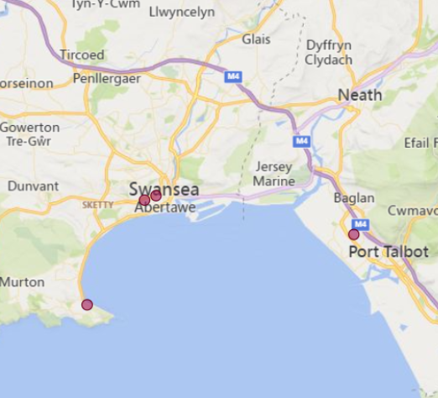  (This map is based on practices approved for the 2025/2026 training year)
Local Allocation Process followed in 2026  (This may be subject to alteration for 2026). | The central recruitment process will allocate you, if appropriate, to the Swansea and West Wales DFT scheme. In line with the rest of the UK, Wales will conduct a local allocation process. Once allocated to your scheme, FDs will be provided with a link to view a profile of each practice on the scheme within the local preferencing window. FDs will be required to submit preferences to HEIW who will allocate based on the FDs National Recruitment ranking. The preferencing window is 10 – 15 June 2026  If you are allocated to the Swansea and West Wales scheme, the Dental Foundation Training Manager will send you further information in June 2026.
Overview | Health care in Wales is a devolved responsibility overseen by the Welsh Government.  As a result, the Welsh General Dental Services contract differs from the arrangements in England. A comprehensive range of training opportunities is available to support professional development.  The Dental Foundation Training salary in Wales is £46,980  Most of the Foundation Training Practices are based in easy commutable distances from Swansea.  The scheme consists of long-standing training practices with many experienced Educational Supervisors committed to Dental Foundation Training.  Swansea and West Wales have a reputation for its scenery, culture, sporting activities, and microbreweries. Swansea's Grand Theatre is a popular venue for everything from opera to comedy and the area hosts several entertaining annual events including a cockle festival, the Mumbles Festival, and the now world-famous Swansea Music Festival. Whilst being a vibrant city, it is a stone throw away from the Gower Peninsula which is  an area of outstanding natural beauty. Gower has magnificent beaches and coastal walks that attract surfers, walkers and sports enthusiasts from far and wide. The capital City of Cardiff is only 40 miles away.  For the sports fans there is always plenty of opportunity to watch the Ospreys and Scarlets rugby teams and Swansea City is now a Championship league football team.  The Study Day centre for the Swansea and West Wales Scheme is based at the Education Centre at Morriston Hospital, Swansea, SA6 6NL. The Education Centre is a new building which opened in the spring of 2015, catering for the needs of young doctors and dentists. The Centre has excellent facilities with an extensive library and IT suite, 13 lecture rooms of varying sizes and many courses and lectures for dentists and DCPs are held there. There is also an excellent clinical skills facility which will accommodate 12 practitioners.  The programme itself is very diverse with networking with other FD schemes, multiple hands –on sessions and if possible external visits to the BDA, GDC, DPL.  You will be encouraged to consider your second-year training scheme (DCT), which also runs from the same Centre. This scheme offers opportunities to develop and expand your range of clinical skills and build your confidence in a supportive environment.  All Welsh schemes offer Foundation Dentists the chance to complete additional learning opportunities such as Quality Improvement projects, which are a positive addition to your CV.  Andrew Matthews is the Training Programme Director for the Swansea and West Wales Scheme. Andrew is a keen sports fan, and he officiates in the second tier of Welsh football. He is also an enthusiastic musician. Over the years several Foundation Dentists have stayed in Swansea and West Wales, many of whom are now Dental Educational Supervisors.  Travelling is easy with the M4 Motorway providing a direct link to Cardiff, London and a link to the rest of England via the M6, M42 and M5. The British Rail services also ensure that Swansea is easily accessible.

Foundation dentists are paid according to the nationally agreed salary in each of the three UK countries involved in this nationally coordinated recruitment process:

- For England and Wales, the exact figure appears in the Statements of Financial Entitlement published periodically by the Departments of Health for England and Wales. For Northern Ireland this is published in the Statement of Dental Remuneration (SDR).
- Please note that the figure published and applicable at the date of application may not be the same as that in force at the time of starting in post.

