2026 DFT National Recruitment

Deanery/NHSE Local Office | Health Education and Improvement Wales (HEIW) | Deanery/NHSE Local Office website address | HEIW - DFT Schemes
Scheme Information | Name of Scheme/Area | Name of TPD | Site and usual day for Educational Programme (Day Release) | Start date
Scheme Information | North Wales | Michael Strother | Glan Clwyd Hospital Rhuddlan Rd, Bodelwyddan, Rhyl LL18 5UJ  and  Wrexham Medical Institute, 62 Croesnewydd Rd, Wrexham LL13 7YX  Dental Academy Bangor  Ty Glyder 337-339  High Street  Bangor  LL57 1PE  Study Day – Friday  [Please note the study days will be delivered as a blended approach]. | 01 September
Geographical spread (towns usually included) Please note - Training practices for 2026 have not yet been appointed. Any information given on our website is for guidance only. | 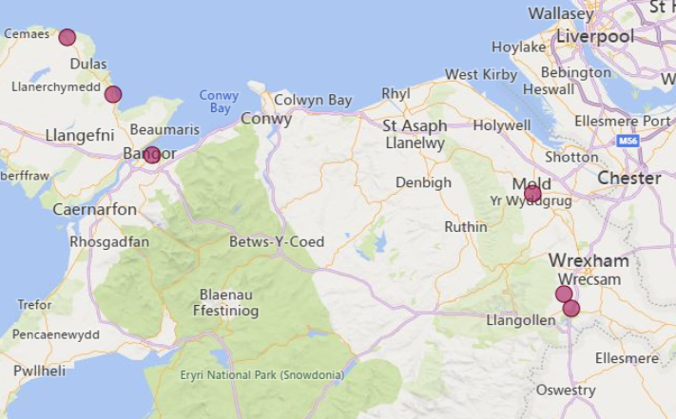  (This map is based on practices approved for the 2025/2026 training year).
Local Allocation Process followed in 2026  (This may be subject to alteration for 2026). | The National Recruitment process will allocate you, if appropriate, to the North Wales DFT scheme. In line with the rest of the UK, Wales will conduct a local allocation process. Once allocated to your scheme, FDs will be provided with a link to view a profile of each practice on the scheme within the local preferencing window. FDs will be required to submit preferences to HEIW who will allocate based on the FDs National Recruitment ranking. The preferencing window is 10 – 15 June 2026  If you are allocated to the North Wales scheme, the Dental Foundation Training Manager will send you further information in June 2026.
Overview | Health care in Wales is a devolved responsibility overseen by the Welsh Government.  As a result, the Welsh General Dental Services contract differs from the arrangements in England. A comprehensive range of training opportunities is available to support professional development.  The Dental Foundation Training salary in Wales is £46,980  The North Wales Dental Foundation year is a long-established scheme with its own distinctive character. Having been established in 1989 it has proved very popular with trainees over the years and launched many successful careers.  North Wales is renowned for its attractive coastal scenery, mountain landscapes and historic sites. Ample opportunities exist for outdoor pursuits including climbing, walking, canoeing and sailing. The National Watersports Centre is at Plas Menai near Caernarfon and the National Mountaineering Centre, Plas y Brenin, is at Capel Curig. There are excellent transport links to Chester, Liverpool, Manchester and Dublin.  The greatest asset of the scheme is the experience of the Educational Supervisors and their high-quality practices. Most Educational Supervisors have been welcoming young dentists to their practices for many years, and their teams often include ex-trainees. Their professional teams are very experienced in ensuring your first year will be memorable, safe and enjoyable. Within all the training practices you will be encouraged to provide the highest standard of dental care. There are opportunities to attend further courses organised by the HEIW in North Wales and to attend Consultant clinics where appropriate.  Friday Study Days are usually held at either Glan Clwyd Hospital (near Bodelwyddan) or Wrexham Medical Institute (near Wrexham Maelor Hospital). This scheme offers opportunities to develop and expand your range of clinical skills and build your confidence in a supportive environment.  For the last 12 months, we have also had the opportunity to utilise the new Dental Academy in Bangor. All the postgraduate centres have a reputation for friendliness, and you will find a very supportive atmosphere from all the centre staff and specialist speakers. The sites have excellent facilities including an extensive library, IT suite and dedicated hands-on training rooms.  The programme itself is very varied with small group teaching, multiple hands–on sessions and visits to Cardiff for conferences/exhibitions. You will be encouraged to consider our second-year training scheme (DCT), which also runs from the same centres.  All Welsh schemes offer Foundation Dentists the chance to complete additional learning opportunities such as Quality Improvement projects, which are a positive addition to your CV.  Michael Strother is the Training Programme Director for the North Wales Scheme. Mike graduated from the University of Liverpool Dental School after initially completing an undergraduate degree in the Liverpool School of Tropical Medicine. He worked in general practice on the Wirral and in Liverpool before moving to North Wales in 2020. He has completed postgraduate training in Clinical Education, is a member of the FDS RCS (Eng) and FDT RCS (Ed), a full member of the CGDent and a Fellow of the HEA. He currently works in Conwy in a mixed NHS/private practice and was an Educational Supervisor before taking the role of Training Programme Director for the North Wales DFT Scheme in August 2024. He is the Secretary of the North Wales LDC and a committee member of the BDA Welsh Council.  If you are interested and enthusiastic, with a desire to continue your training in a fully supportive and friendly educational environment situated in an area with a range of amenities and opportunities, we would be delighted to meet you.

Foundation dentists are paid according to the nationally agreed salary in each of the three UK countries involved in this nationally coordinated recruitment process:

- For England and Wales, the exact figure appears in the Statements of Financial Entitlement published periodically by the Departments of Health for England and Wales. For Northern Ireland this is published in the Statement of Dental Remuneration (SDR).
- Please note that the figure published and applicable at the date of application may not be the same as that in force at the time of starting in post.

