2026 DFT National Recruitment

Deanery/NHSE Local Office | Health Education and Improvement Wales (HEIW) | Deanery/NHSE Local Office website address | HEIW - DFT Schemes
Scheme Information | Name of Scheme/Area | Name of TPD | Site and usual day for Educational Programme (Day Release) | Start date
Scheme Information | Newport and East Wales | Catherine Nelson | The Routledge Academic Centre, University Hospital Llandough, Penlan Road, Penarth, Cardiff CF64 2XX  Study Day – Thursday  Please note the study day programme is delivered as a blended approach | 01 September
Geographical spread (towns usually included) Please note - Training practices for 2026 have not yet been appointed. Any information given on our website is for guidance only. | 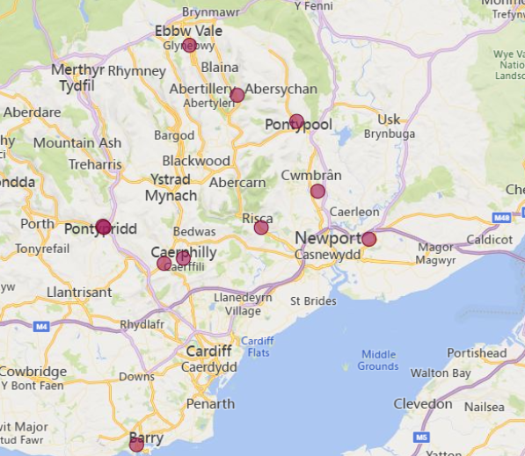  (This map is based on practices approved for the 2025/2026 training year)
Local Allocation Process followed in 2026  (This may be subject to alteration for 2026). | The National Recruitment process will allocate you, if appropriate, to the Newport and East Wales DFT scheme. In line with the rest of the UK, Wales will conduct a local allocation process. Once allocated to your scheme, FDs will be provided with a link to view a profile of each practice on the scheme within the local preferencing window. FDs will be required to submit preferences to HEIW who will allocate based on the FDs National Recruitment ranking. The preferencing window is 10 – 15 June 2026  If you are allocated to the Newport and East Wales scheme, the Dental Foundation Training Manager will send you further information in June 2026.
Overview | Health care in Wales is a devolved responsibility overseen by the Welsh Government.  As a result, the Welsh General Dental Services contract differs from the arrangements in England. A comprehensive range of training opportunities is available to support professional development.  The Dental Foundation Training salary in Wales is £46,980  The Newport and East Wales Scheme normally comprises of practices within easy driving distance of Cardiff, Newport and Pontypridd. The practices are well equipped with good staff and ample patient numbers. The Foundation Dentists would have lots of experience of routine clinical dentistry and would also benefit from the Educational Supervisors’ own special interests.  The surrounding areas are a mixture of cities with good shops and entertainment, smaller towns and lovely countryside with good opportunities for outdoor and sporting activities. Newport enjoys several sites and landmarks worth noting, such as the beautifully restored Tredegar House (ideal for history and picnicking), the Newport Wetlands, the Transporter Bridge and the Wales National Velodrome.  Cardiff is close by, has excellent cultural and international sporting opportunities and is a lively, elegant city catering for all tastes. Many trainees, upon completion of their training year, are happy to settle within the area.  The study days are based at the Routledge Academic Centre, within Llandough Hospital, which has easy access and plenty of parking on site. The Centre has excellent facilities, including dental units for hands-on training, fully equipped lecture and seminar rooms, IT facilities and library. There are canteen and restaurant facilities within the hospital complex.  The Newport and East Wales study day programme is a varied mixture of multiple hands-on clinical sessions, seminars and interactive presentations.  This scheme offers opportunities to develop and expand your range of clinical skills and build your confidence in a supportive environment.  All Welsh schemes offer Foundation Dentists the chance to complete additional learning opportunities such as Quality Improvement projects, which are a positive addition to your CV.  The Training Programme Director for the Newport and East Wales Scheme is Catherine Nelson. Catherine was previously a TPD for the Telford Scheme in the West Midlands for 7 years, before relocating to South Wales 9 years ago.  Catherine aims to ensure that the Foundation Dentists on the Newport and East Wales Scheme have a good training year and that everything runs smoothly and efficiently. The Newport and East Wales Scheme is a friendly, supportive and effective environment for Foundation Dentists to establish good foundations for their future careers.  Catherine is passionate about opportunities in general practice and career pathways for dentists. Previously she established and ran a 6 surgery, mainly NHS practice, in Shropshire for 15 years. The practice was committed to training dentists and other members of the wider Dental Team.

Foundation dentists are paid according to the nationally agreed salary in each of the three UK countries involved in this nationally coordinated recruitment process:

- For England and Wales, the exact figure appears in the Statements of Financial Entitlement published periodically by the Departments of Health for England and Wales. For Northern Ireland this is published in the Statement of Dental Remuneration (SDR).
- Please note that the figure published and applicable at the date of application may not be the same as that in force at the time of starting in post.

