2026 DFT National Recruitment

Deanery/NHSE Local Office | Health Education and Improvement Wales (HEIW) | Deanery/NHSE Local Office website address | HEIW - DFT Schemes
Scheme Information | Name of Scheme/Area | Name of TPD | Site and usual day for Educational Programme (Day Release) | Start date
Scheme Information | Glamorgan Vale and Beacons | Robert Davies | Dental Teaching Unit Porth, Leith House, Pontypridd Rd, Porth CF39 9PH – Friday  Please note our study day programmes are delivered as a blended approach | 01 September
Geographical spread (towns usually included) Please note - Training practices for 2026 have not yet been appointed. Any information given on our website is for guidance only. | 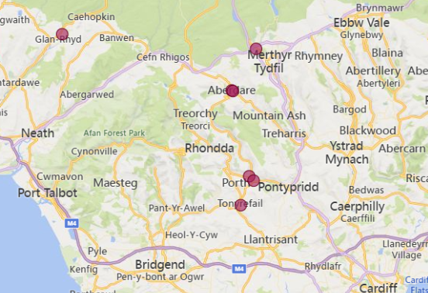  (This map is based on practices approved for the 2025/2026 training year)
Local Allocation Process followed in 2026  (This may be subject to alteration for 2026). | The National Recruitment process will allocate you, if appropriate, to the Glamorgan Vale and Beacons DFT scheme. In line with the rest of the UK, Wales will conduct a local allocation process. Once allocated to your scheme, FDs will be provided with a link to view a profile of each practice on the scheme within the local preferencing window. FDs will be required to submit preferences to HEIW who will allocate based on the FDs National Recruitment ranking. The preferencing window is 10 – 15 June 2026.  If you are allocated to the Glamorgan Vale and Beacons scheme, the Dental Foundation Training Manager will send you further information in June 2026.
Overview | Health care in Wales is a devolved responsibility overseen by the Welsh Government.  As a result, the Welsh General Dental Services contract differs from the arrangements in England. A comprehensive range of training opportunities is available to support professional development.  The Dental Foundation Training salary in Wales is £46,980  Most of the Glamorgan Vale and Beacons practices are based in easy commutable distances from Cardiff.  The scheme consists of long-standing training practices with experienced Educational Supervisors committed to Dental Foundation Training and offering outstanding experience.  Nearby Cardiff boasts a wide range of cultural and international sporting opportunities and is a lively, elegant city, catering for all tastes. From the excitement of a vibrant city life to the peace and tranquillity of the nearby coast and countryside, the attractive Brecon Beacons National Park is conveniently close. It is a city with both heritage and ambition and benefits from excellent road, rail and airport links. Many trainees, upon completion of their training year, are happy to settle within the area.  The Study Day Programme for the Glamorgan Vale and Beacons Scheme will usually be held at the Dental Teaching Unit in Porth. The Dental Teaching Unit is a facility which accommodates a hands-on training room with eighteen phantom heads and a lecture theatre which seats a maximum of 100 people. The Unit has a complete range of IT facilities equipped with plasma screens, demonstration cameras and WiFi access.  The Unit is a short walking distance from Porth train station (catch the Valley line train to Treherbert, approximately every 30 minutes and get off at Porth, which is only a 40-minute journey from Cardiff Central station) and easy car parking in the surrounding area.  The Glamorgan Vale and Beacons scheme has a mixture of seminar presentations, workshops, hands-on sessions, practice visits and regional conferences. Topics are varied and subject to constant review, but may typically include Crown and Bridgework, Adhesive dentistry, Oral Surgery, Endodontics, Ethical and Legal Issues, Financial Management and Understanding the NHS Regulations, Child Protection, plus many other core subjects.  This scheme offers opportunities to develop and expand your range of clinical skills and build your confidence in a supportive environment.  All Welsh schemes offer Foundation Dentists the chance to complete additional learning opportunities such as Quality Improvement projects, which are a positive addition to your CV.  The Dental Foundation Training Programme Director, Rob Davies, has been the Training Programme Director for the scheme since it first started in 2011 and has been an Educational Supervisor for 15 years prior to this role. Rob’s attitude towards Dental Foundation Training has always been that it should be an enjoyable and informative year whilst adopting high professional standards, gaining as much experience as possible in a supportive environment based on sound mentoring principles.  Please be advised that, HEIW will offer two Longitudinal posts, each comprising one year in a DFT position followed by one year in a DCT position. This provides a continuous two-year development opportunity. These DFT posts will be included on the Glamorgan Vale and Beacons DFT scheme. For more information on this offer please visit the DFT and DCT Longitudinal Training Offer template.

Foundation dentists are paid according to the nationally agreed salary in each of the three UK countries involved in this nationally coordinated recruitment process:

- For England and Wales, the exact figure appears in the Statements of Financial Entitlement published periodically by the Departments of Health for England and Wales. For Northern Ireland this is published in the Statement of Dental Remuneration (SDR).
- Please note that the figure published and applicable at the date of application may not be the same as that in force at the time of starting in post.

