2026 DFT National Recruitment

Deanery/NHSE Local Office | Health Education and Improvement Wales (HEIW) | Deanery/NHSE Local Office website address | HEIW - DFT Schemes
Scheme Information | Name of Scheme/Area | Name of TPD | Site and usual day for Educational Programme (Day Release) | Start date
Scheme Information | Cardiff and Barry | Richard Jones | Education Centre, University Hospital Llandough, Penlan Road, Penarth, Cardiff CF64 2XX  Study Day - Friday  Please note our study day programmes are delivered as a blended approach | 01 September
Geographical spread (towns usually included) Please note - Training practices for 2026 have not yet been appointed. Any information given on our website is for guidance only. | 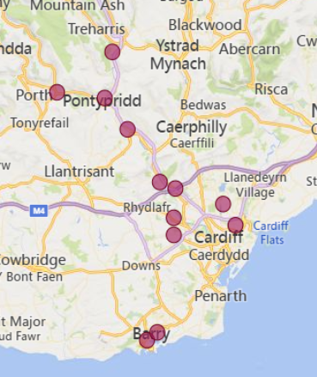  (This map is based on practices approved for the 2025/2026 training year)
Local Allocation Process followed in 2026  (This may be subject to alteration for 2026). | The National Recruitment process will allocate you, if appropriate, to the Cardiff and Barry DFT scheme. In line with the rest of the UK, Wales will conduct a local allocation process. Once allocated to your scheme, FDs will be provided with a link to view a profile of each practice on the scheme within the local preferencing window. FDs will be required to submit preferences to HEIW who will allocate based on the FDs National Recruitment ranking. The preferencing window is 10 – 15 June 2026  If you are allocated to the Cardiff and Barry scheme, the Dental Foundation Training Manager will send you further information in June 2026
Overview | Health care in Wales is a devolved responsibility overseen by the Welsh Government.  As a result, the Welsh General Dental Services contract differs from the arrangements in England. A comprehensive range of training opportunities is available to support professional development.  The Dental Foundation Training salary in Wales is £46,980  The Cardiff and Barry scheme is comprised of practices located in Cardiff, surrounding areas and the A470 corridor. The scheme has proved to be a popular scheme over the years due to the convenience of its location and the outstanding practices in this area.  Cardiff boasts a wide range of cultural and international sporting opportunities and is a lively, elegant city catering for all tastes. From the excitement of a vibrant city life to the peace and tranquility of the nearby coast and countryside, the attractive Brecon Beacons National Park is conveniently close. Cardiff is the home to the Principality Stadium and many legislative buildings. It is a city with both heritage and ambition and benefits from excellent road, rail and airport links. Many trainees, upon completion of their training year, are happy to settle within the area.  The Study Day centre for the Cardiff and Barry Scheme is based in the Postgraduate Centre at Llandough Hospital, which is situated approximately 4 miles from Cardiff city centre, the capital city of Wales.  The Dental Postgraduate Centre is situated within the Academic Building of Llandough Hospital, which has easy access and plenty of parking on site. The Centre has excellent facilities, including dental units for hands-on training and fully equipped lecture and seminar rooms, IT facilities and library. There are canteen and restaurant facilities within the hospital complex.  The Cardiff and Barry scheme has a mixture of blended learning seminar presentations, workshops, and multiple ‘hands-on’ sessions, practice visits and conferences. Topics are varied, and subject to constant review, but may typically include an initial clinical skills hands-on refresher session, Child Protection, Oral Surgery, Health and Safety, Endodontics, Ethical and Legal Issues, Financial Management and Understanding the NHS Regulations, plus many other subjects.  This scheme offers opportunities to develop and expand your range of clinical skills and build your confidence in a supportive environment.  All Welsh schemes offer Foundation Dentists the chance to complete additional learning opportunities such as Quality Improvement projects, which are a positive addition to your CV.  The Training Programme Director, Richard Jones, has worked in General Dental Practice since 1994, being part of the first compulsory Vocational Training cohort. He has been a Partner in practice for over 20 years having also worked in Morriston Hospital’s Restorative department from 1995 to 2003 as a Clinical Assistant. His dental practice has also been heavily involved with contract reform. Currently he also works for CTM Health Board as a Primary Care Dental Practice Advisor and is a Dental Tutor with HEIW. He will provide you with support to practice safely within your own competence levels.
Foundation dentists are paid according to the nationally agreed salary in each of the three UK countries involved in this nationally coordinated recruitment process:

- For England and Wales, the exact figure appears in the Statements of Financial Entitlement published periodically by the Departments of Health for England and Wales. For Northern Ireland this is published in the Statement of Dental Remuneration (SDR).
- Please note that the figure published and applicable at the date of application may not be the same as that in force at the time of starting in post.

